Employee database(extra queries)
create database employeee;
use employeee;
CREATE TABLE Dept (
Dno INT PRIMARY KEY,
Dname VARCHAR(30),
Dloc VARCHAR(50)
);
CREATE TABLE Employee (
Eno INT PRIMARY KEY,
Ename VARCHAR(50),
Mgrno INT,
Hiredate DATE,
Sal DECIMAL(10,2),
Deptno INT,
FOREIGN KEY (Deptno) REFERENCES Dept(Dno)
);
CREATE TABLE Project (
Pno INT PRIMARY KEY,
Pname VARCHAR(50),
Ploc VARCHAR(50)
);
CREATE TABLE Assignd_To (
Eno INT,
Dno INT,
JobRole VARCHAR(50),
PRIMARY KEY (Eno),
FOREIGN KEY (Eno) REFERENCES Employee(Eno),
FOREIGN KEY (Dno) REFERENCES Dept(Dno)
);
CREATE TABLE incentives (
Eno INT,
Pno INT,
Amount DECIMAL(10,2),
Adate DATE,
PRIMARY KEY (Eno, Pno),
FOREIGN KEY (Eno) REFERENCES Employee(Eno),
FOREIGN KEY (Pno) REFERENCES Project(Pno)
);

INSERT INTO Dept (Dno, Dname, Dloc)
VALUES
(10, 'HR', 'Mumbai'),
(20, 'IT', 'Bangalore'),
(30, 'Finance', 'Delhi'),
(40, 'Marketing', 'Chennai'),
(50, 'Operations', 'Hyderabad');

INSERT INTO Employee (Eno, Ename, Mgrno, Hiredate, Sal, Deptno) VALUES
(101, 'Rajesh', NULL, '2019-03-12', 55000, 10),
(102, 'Sneha', 101, '2020-07-19', 48000, 20),
(103, 'Kiran', 101, '2021-01-25', 42000, 20),
(104, 'Priya', 102, '2022-05-10', 40000, 30),
(105, 'Aryan', 103, '2023-09-15', 38000, 20);

INSERT INTO Project (Pno, Pname, Ploc) VALUES
(201, 'Recruitment', 'Mumbai'),
(202, 'ERP Upgrade', 'Bangalore'),
(203, 'Audit System', 'Delhi'),
(204, 'Product Launch', 'Chennai'),
(205, 'Logistics Hub', 'Hyderabad');

INSERT INTO Assignd_To (Eno, Dno, JobRole) VALUES
(101, 10, 'Manager'),
(102, 20, 'Analyst'),
(103, 20, 'Coordinator'),
(104, 30, 'Accountant'),
(105, 20, 'Software Engineer');

INSERT INTO incentives (Eno, Pno, Amount, Adate) VALUES
(101, 202, 1000, '2024-01-10'),
(102, 204, 500, '2024-06-25'),
(103, 204, 800, '2024-07-18'),
(104, 205, 600, '2024-09-12'),
(105, 202, 400, '2024-12-05');

SELECT * FROM Dept;
SELECT * FROM Employee;
SELECT * FROM Project;
SELECT * FROM Assignd_To;
SELECT * FROM incentives;

select e.Ename , d.Dname,d.Dloc
from employee e
inner join dept d on e.deptNo = d.DNo;
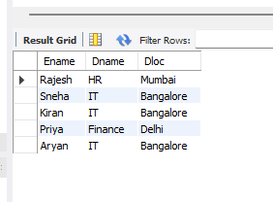

select e.Ename ,e.Eno
from employee e
left join Assignd_To a on e.eno = a.eno
where a.eno is null;

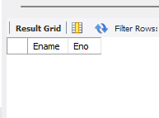

SELECT
p.Pname AS Project_Name,
COUNT(i.Eno) AS Headcount
FROM
Project p
LEFT JOIN
incentives i ON p.Pno = i.Pno
GROUP BY
p.Pname
ORDER BY
Headcount DESC;
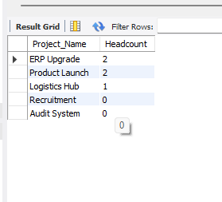

SELECT
d.Dname AS Department_Name,
ROUND(AVG(e.Sal), 2) AS Average_Salary,
MAX(e.Sal) AS Max_Salary
FROM
Employee e
INNER JOIN
Dept d ON e.Deptno = d.Dno
GROUP BY
d.Dname
ORDER BY
Average_Salary DESC;
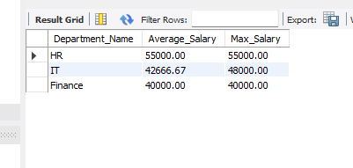

SELECT
e.Eno,
e.Ename,
COALESCE(SUM(i.Amount), 0) AS Total_Incentives
FROM
Employee e
LEFT JOIN
incentives i ON e.Eno = i.Eno
GROUP BY
e.Eno, e.Ename
ORDER BY
Total_Incentives DESC;
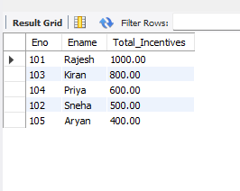

SELECT
e.Eno,
e.Ename,
p.Pname AS Project_Name,
i.Amount AS Incentive_Amount,
i.Adate AS Incentive_Date
FROM
Employee e
INNER JOIN
incentives i ON e.Eno = i.Eno
INNER JOIN
Project p ON i.Pno = p.Pno
WHERE
p.Pname = 'Alpha Project';


SELECT
d.Dno,
d.Dname,
d.Dloc
FROM
Dept d
LEFT JOIN
Employee e ON d.Dno = e.Deptno
WHERE
e.Eno IS NULL;
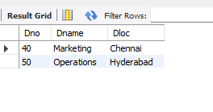

SELECT
m.Eno AS Manager_ID,
m.Ename AS Manager_Name,
COUNT(e.Eno) AS Direct_Report_Count
FROM
Employee m
LEFT JOIN
Employee e ON m.Eno = e.Mgrno
GROUP BY
m.Eno, m.Ename
ORDER BY
Direct_Report_Count DESC;

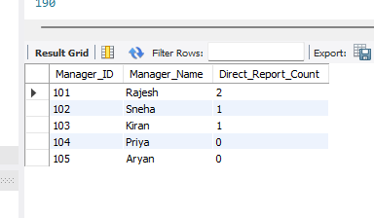

SELECT
e.Eno,
e.Ename,
COUNT(i.Pno) AS Project_Count
FROM
Employee e
INNER JOIN
incentives i ON e.Eno = i.Eno
GROUP BY
e.Eno, e.Ename
HAVING
COUNT(i.Pno) > 1
ORDER BY
Project_Count DESC;



